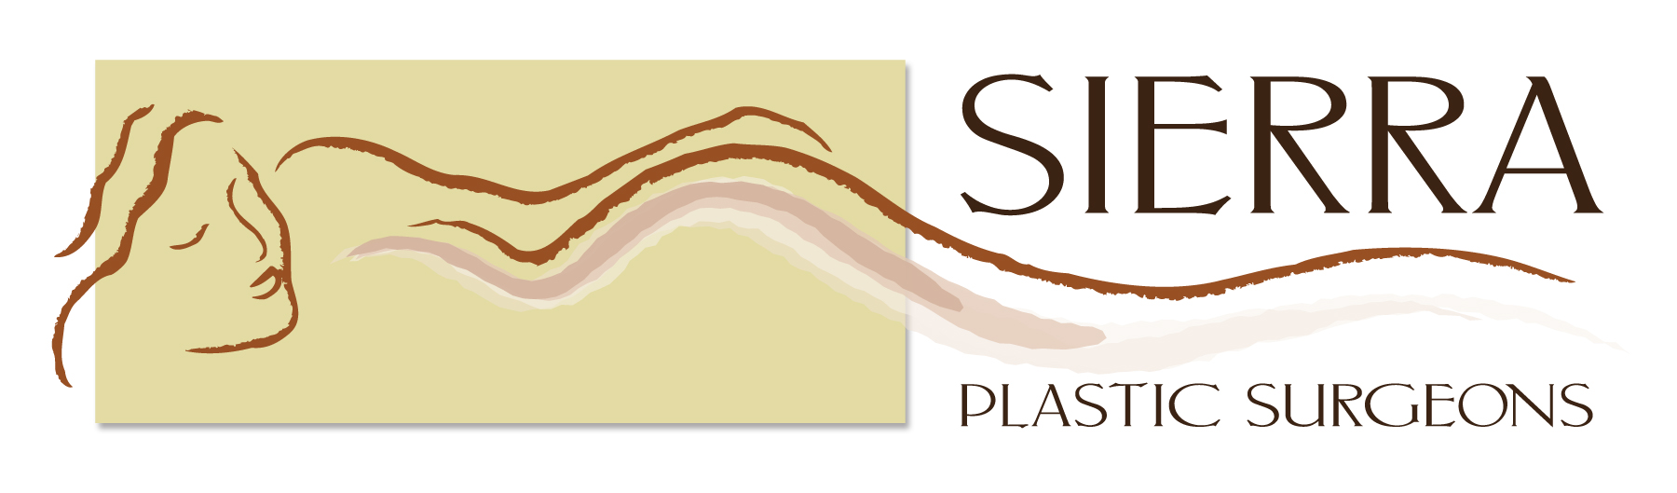
Kaye M. Riolo, M.D., F.A.C.S.
T (559) 256-7700 • F (559) 256-7711 6145 N. Thesta

John F. Burnett, M.D.
T (559) 432-5156 • F (559) 432-8812
1105 E. Spruce Ave., Ste. 203
Fresno, CA 93720

PATIENT INFORMATION

Patient Name______________________________ M_____F____ Email _________________

Address__________________________________________________City_________________Zip____________

Age______ Date of Birth ________________SS# ___________________Marital Status M__S__W__D__DP__
(optional)

Phone No: Hm______________________Cell______________________Wk____________________Ext______

Referring MD_________________ Phone:_______________ Primary Care:______________ Ph._____________

Other Doctors you want to have copies: _________________________________________________________

Pharmacy for prescriptions: ____________________________________Phone:_________________________

Employer__________________________________________Occupation_________________________________
Employment Address: ______________________________________ Zip__________Phone _________________

Spouse/DP____________________ Social Security #:_____________________Date of Birth_____________
Spouse employer_______________________________________________________________________
Employer Address _________________________________________Phone _______________________

If no one is home, whom do you authorize us to contact in case of emergency?__________________
Ph.# ____________________Relationship_______________________
Insurance Information:
Policyholder’s Name______________________________ID:____________________DOB:__________
Relationship to patient:__________________________________________________________________

***PLEASE GIVE ALL CARDS TO RECEPTIONIST FOR COPYING***

ASSIGNMENT OF BENEFITS:
I hereby assign all Medical and/or Surgical Benefits, to include Major Medical Benefits to which I am entitled, (including Medicare, Medi-Cal, Private insurance and any other health plan) to Sierra Plastic Surgeons for all charges, whether or not they are paid by said insurance. I authorize Sierra Plastic Surgeons to release to the Health Care Financing Administration and its agents, any information needed to determine these benefits payable for related services. A photocopy of this assignment is to be considered as valid as an original.
I further authorize Sierra Plastic Surgeons to furnish my insurance company all medical information which the insurance company may request for the evaluation of claims. I also authorize the release of my referring physician, records concerning my illness or injury.

Signature:________________________________Date____________________________
(Patient or guardian)

▪

Dear Patients:

This preliminary letter will answer the most common questions. If you wish to contact our office, the telephone is answered from 9a.m-5p.m.

Schedule of Fees

The fee for your initial examination may vary depending on the extent of the visit. We require payment in full at this time unless we are contracted with your insurance company to bill them directly, or other arrangements have been made with you in advance with our billing office. We will bill primary and secondary insurance only. When we bill your insurance company and they have not paid within 60 days, the balance will become your responsibility.

Surgery

Prior to surgery, you are responsible to provide our office with all the necessary insurance information for your billing. We also require that you pay for any elective surgeries that are not covered under your policy in full, 14 days prior to the day of your surgery. In some cases, we may require you pay for the percentage (ex: deductible plus 20%) your insurance will not be paying.

Disability

We have State Disability forms in the office for your convenience. If you need one, please feel free to ask for one.

Delinquent Accounts

If you receive a statement from our office that you do not understand, please call our office at 559-256-7700 or 559-432-5156 to discuss your account. Once you have received a statement, it is your responsibility to pay the account. If there is no action on the account for more than 90 days, the account will be sent to a collection agency for further collection attempts.

I HAVE READ THE TERMS ABOVE AND AGREE TO GUARANTEE PAYMENT.

Signature____________________________________Date_______________________
(Patient or guardian)

Medical Records Privacy

It is the policy of Sierra Plastic Surgeons to maintain the privacy of the Medical Records we use. Our records include our evaluations and recommendations, copies of laboratory studies, X-ray and other studies, as well as consultations from other physicians. Some of the records are actually from the hospital and are included in the file. The Medical Record also includes letters to your referring physician and other consultants involved in your care. Finally, the record contains certain demographic information and your insurance information.

We, at Sierra Plastic Surgeons are always concerned about the Privacy of these records. It is our policy not to release any information from these records to others without your written permission. The only exceptions to this rule are records we send to your referring physician and consultants and the occasional request by your Insurance Company (If you are not aware, most Insurance Companies have you sign a Medical Information Release Form when you sign up with them).

We do not release information from the record unless you request and sign a release form. You have the right to specify which portion of the record we may release. Other than the exceptions mentioned above, Sierra Plastic Surgeons will maintain a separate record of the date any information was sent and to whom it was sent. A nominal fee may be charged for the copying of the medical record.

If you have any questions about the Medical Record, feel free to ask our staff or your Physician here at Sierra Plastic Surgeons.

Signature____________________________________Date_______________________
(Patient or guardian)

Consent for Purposes of Treatment, Payment and Healthcare Operations for Sierra Plastic Surgeons.

I consent to the use or disclosure of my protected health information by Sierra Plastic Surgeons for the purpose of diagnosing or providing treatment to me, obtaining payment for my health care bills or to conduct health care operations of Sierra Plastic Surgeons. I understand that diagnosis or treatment of me by Kaye M. Riolo, M.D. or John F. Burnett, M.D., may be conditioned upon my consent as evidenced by my signature on this document.

I understand I have the right to request a restriction as to how my protected health information is used or disclosed to carry out treatment, payment or healthcare operations of the practice. Sierra Plastic Surgeons is not required to agree to the restrictions that I may request. However, if Sierra Plastic Surgeons agrees to a restriction that I request, the restriction is binding on Sierra Plastic Surgeons, and physicians, Kaye M. Riolo, M.D. and John F. Burnett, M.D.

I have the right to revoke this consent, in writing, at any time, except to the extent that Kaye M. Riolo, M.D., John F. Burnett, M.D., or Sierra Plastic Surgeons have taken action in reliance on this consent.

My "protected health information" means health information, including my demographic information, collected from me and created or received by my physician, another health care provider, a health plan, my employer or a health care clearinghouse. This protected health information relates to my past, present or future physical or mental health or condition and identifies me, or there is a reasonable basis to believe the information may identify me.

I understand I have a right to review Sierra Plastic Surgeons’ Notice of Privacy Practices prior to signing this document. The Sierra Plastic Surgeons’ Notice of Privacy Practices has been provided to me. The Notice of Privacy Practices describes the types of uses and disclosures of my protected health information that will occur in my treatment, payment of my bills or in the performance of health care operations of the Sierra Plastic Surgeons. The Notice of Privacy Practices for Sierra Plastic Surgeons is also provided in the waiting room of Sierra Plastic Surgeons, 1105 E Spruce Ave., Ste. 203, Fresno, CA. 93720. This Notice of Privacy Practices also describes my rights and the duties of Sierra Plastic Surgeons with respect to my protected health information.

Sierra Plastic Surgeons reserves the right to change the privacy practices that are described in the Notice of Privacy Practices. I may obtain a revised notice of privacy practices by calling the office and requesting a revised copy be sent in the mail or asking for one at the time of my next appointment.

Signature _________________________________ Date __________________________

